Encoder
# Source: AI Source: Provided by: [Data Path: Persons Table -> ID Column: 1, Name_En Column: Motasem Essam] -> From: [ChatGPT] on [7/17/2026]
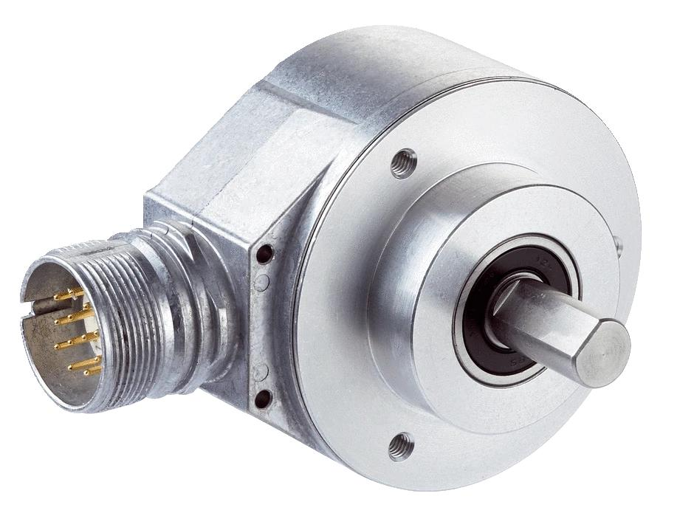
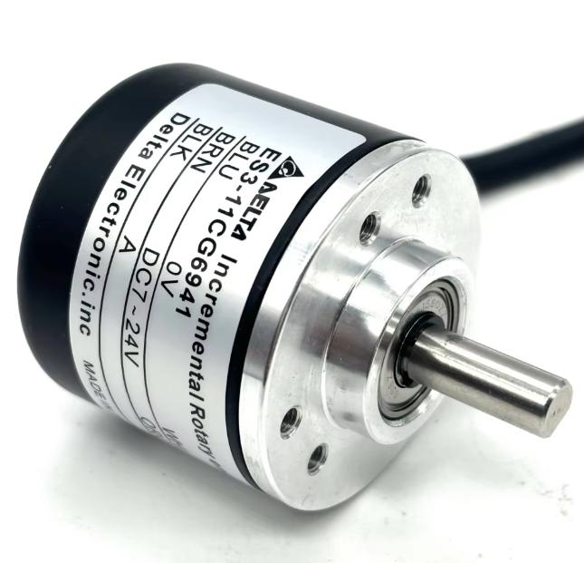
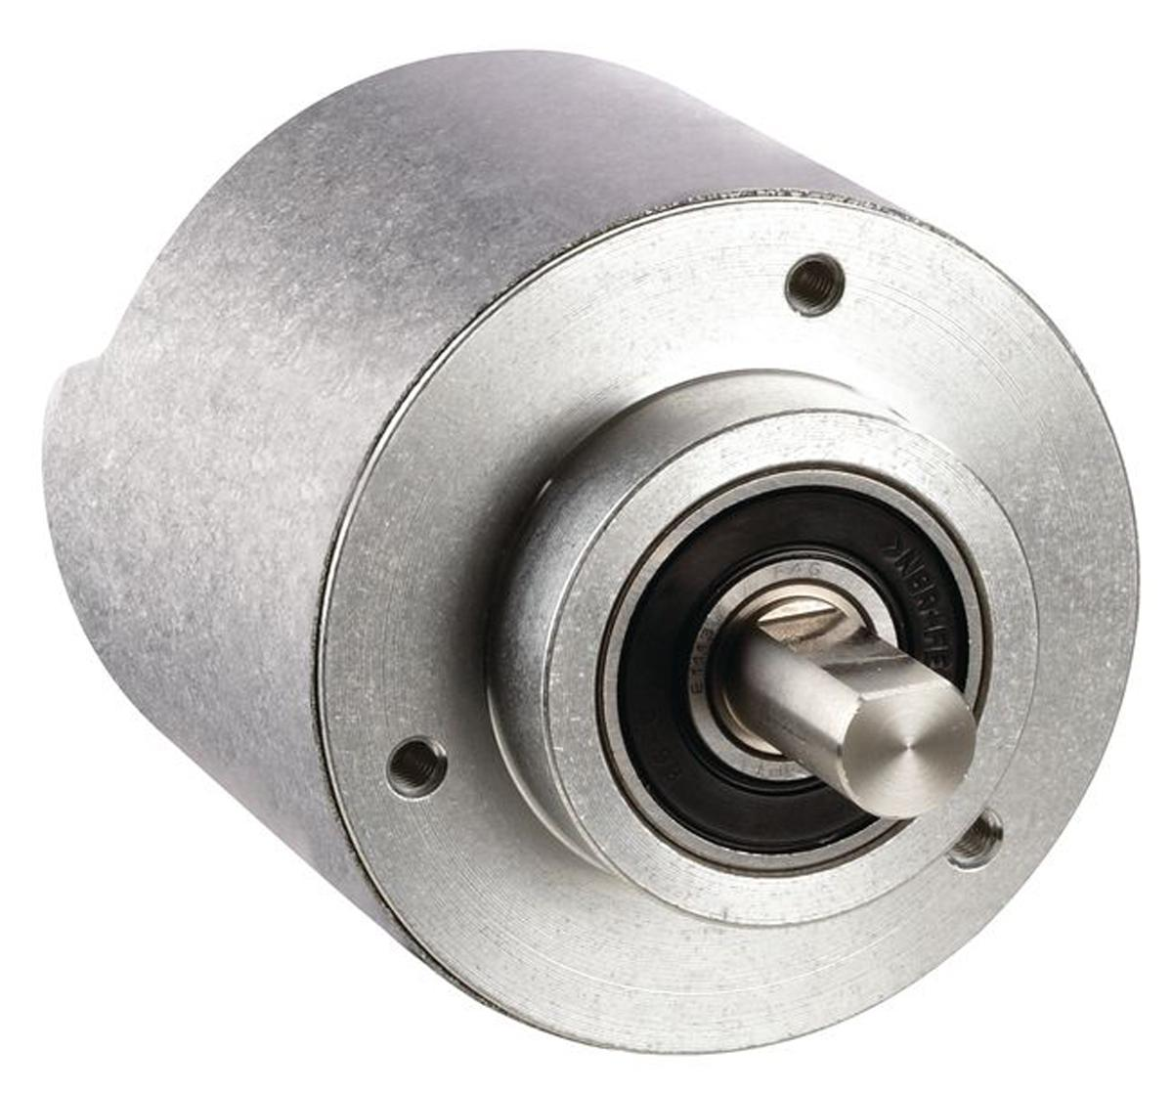
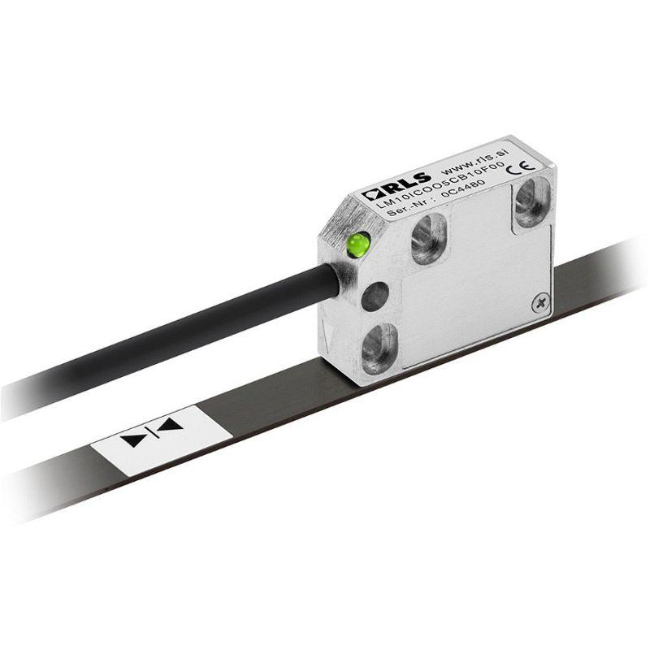
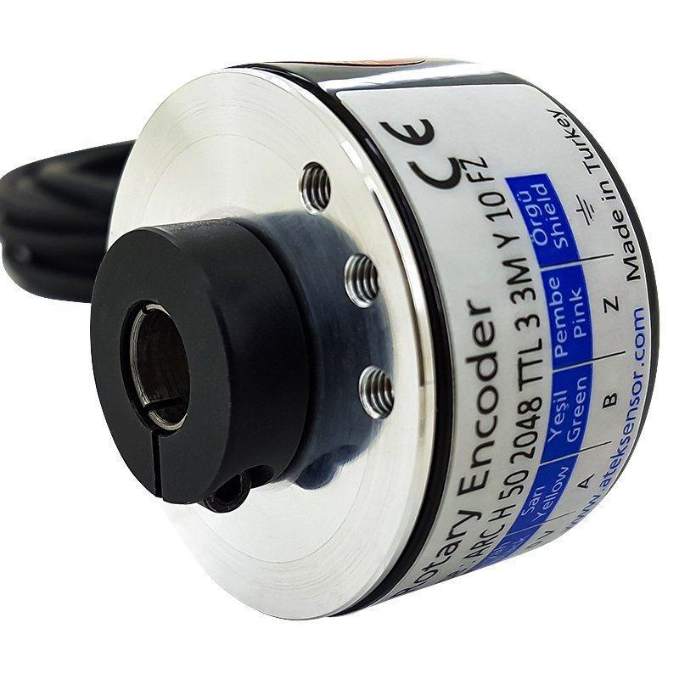
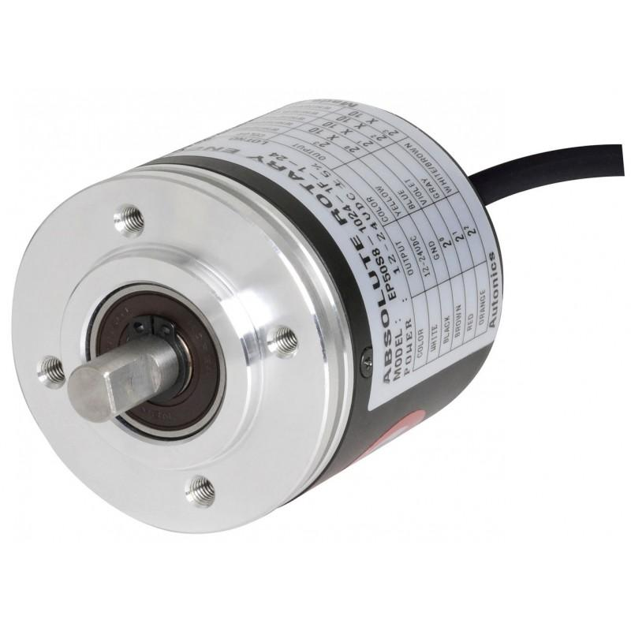
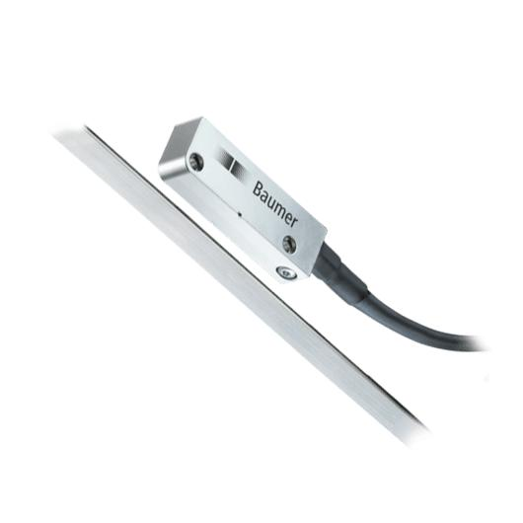
An Encoder is an electromechanical sensor that converts rotational or linear motion into electrical signals. These signals are used to determine speed, position, direction, distance, or angular displacement. Encoders are widely used in industrial automation, robotics, CNC machines, conveyor systems, servo motors, and motion control applications.

Definition
# Source: AI Source: Provided by: [Data Path: Persons Table -> ID Column: 1, Name_En Column: Motasem Essam] -> From: [ChatGPT] on [7/17/2026]
An Encoder is a motion sensor that converts mechanical movement into electrical pulses or digital signals to measure speed, position, direction, or displacement.

Purpose
# Source: AI Source: Provided by: [Data Path: Persons Table -> ID Column: 1, Name_En Column: Motasem Essam] -> From: [ChatGPT] on [7/17/2026]
An encoder is used to:
- Measure rotational speed (RPM).
- Measure linear speed.
- Determine shaft position.
- Detect movement direction.
- Control servo and stepper motors.
- Provide feedback in automation systems.

Principle of Operation
# Source: AI Source: Provided by: [Data Path: Persons Table -> ID Column: 1, Name_En Column: Motasem Essam] -> From: [ChatGPT] on [7/17/2026]
An encoder detects movement using an internal sensing mechanism (optical, magnetic, capacitive, or inductive).
As the shaft or linear scale moves:
- The encoder generates electrical pulses or digital codes.
- The control system counts these signals.
- Speed and position are calculated from the pulse frequency and count.

Main Components
# Source: AI Source: Provided by: [Data Path: Persons Table -> ID Column: 1, Name_En Column: Motasem Essam] -> From: [ChatGPT] on [7/17/2026]
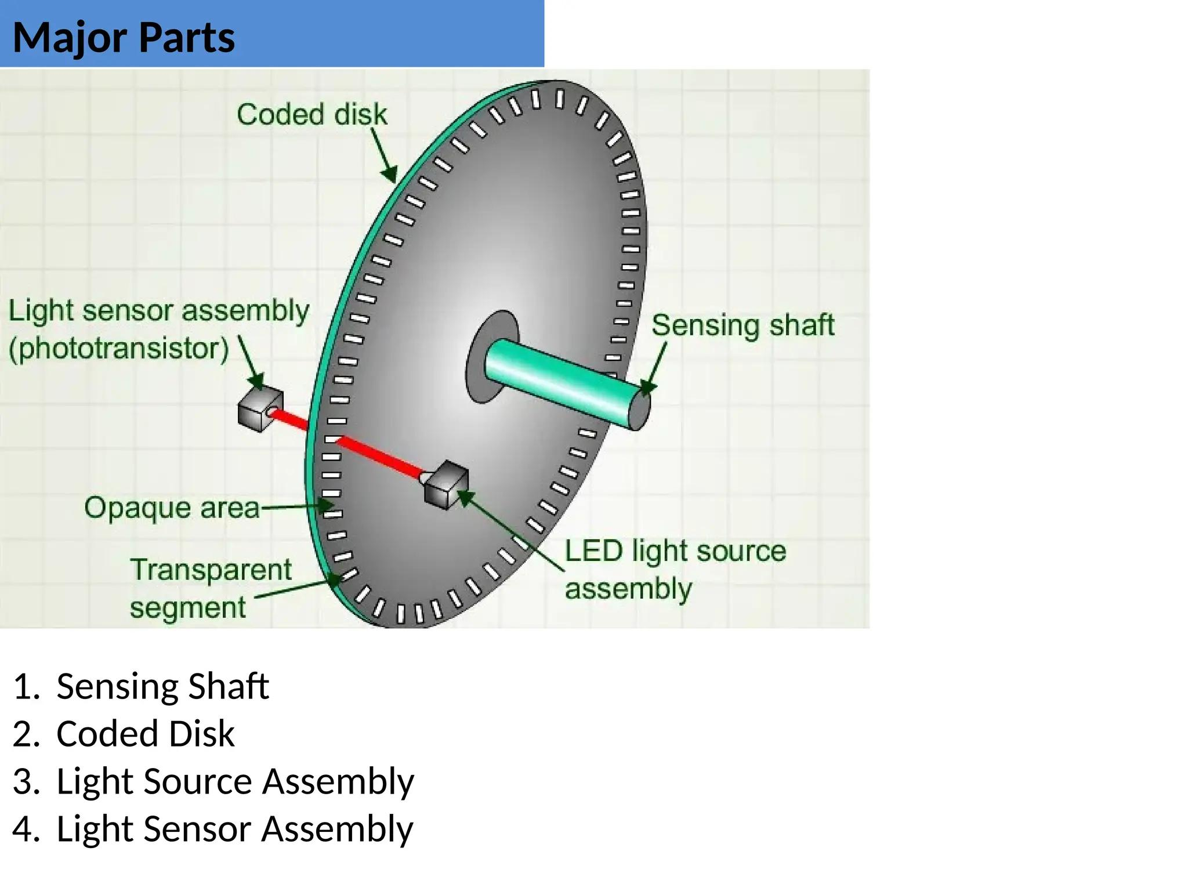
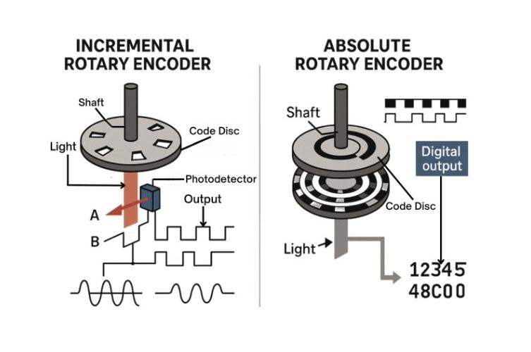
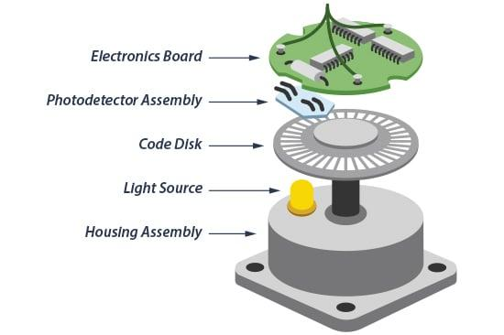
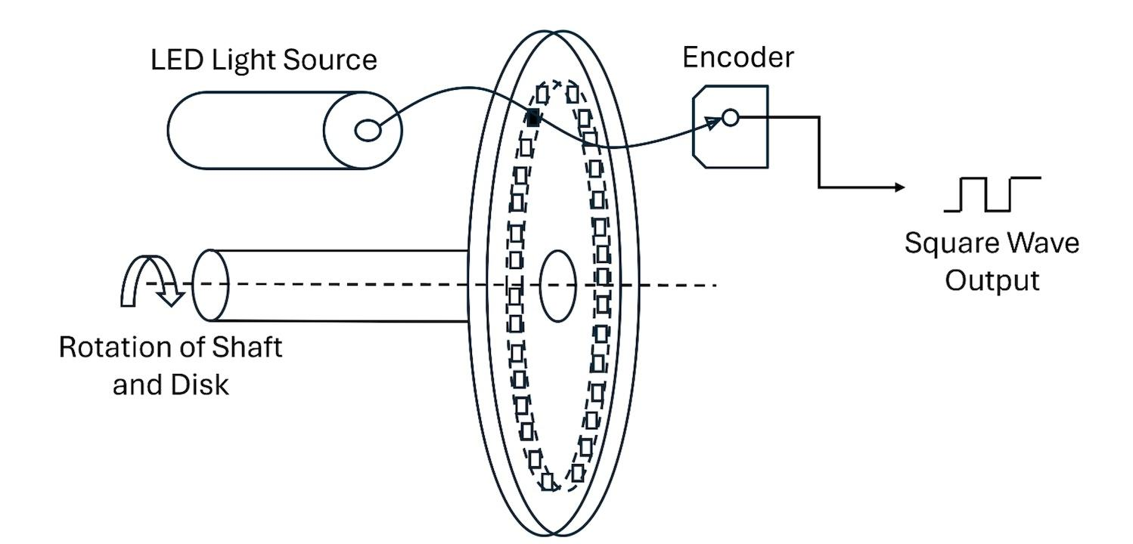
A typical encoder consists of:
- Rotating shaft or linear scale
- Encoding disk or magnetic ring
- Sensor (optical, magnetic, etc.)
- Signal processing electronics
- Output connector
- Housing and bearings

Types of Encoders

1. Incremental Encoder
# Source: AI Source: Provided by: [Data Path: Persons Table -> ID Column: 1, Name_En Column: Motasem Essam] -> From: [ChatGPT] on [7/17/2026]


Description
Produces pulses as the shaft rotates. Position is determined by counting pulses.
Features
- High-speed operation
- Simple design
- Excellent for speed measurement
Applications
- Motor speed control
- Conveyor systems
- Robotics
- CNC machines

2. Absolute Encoder
# Source: AI Source: Provided by: [Data Path: Persons Table -> ID Column: 1, Name_En Column: Motasem Essam] -> From: [ChatGPT] on [7/17/2026]


Description
Provides a unique digital code for every shaft position, allowing the exact position to be known even after power loss.
Features
- No homing required
- Retains position information
- High precision
Applications
- Robotics
- Servo systems
- Industrial automation
- Aerospace

3. Linear Encoder
# Source: AI Source: Provided by: [Data Path: Persons Table -> ID Column: 1, Name_En Column: Motasem Essam] -> From: [ChatGPT] on [7/17/2026]


Description
Measures straight-line movement instead of rotational motion.
Applications
- CNC machines
- Coordinate measuring machines (CMM)
- Precision manufacturing
- Position measurement

4. Magnetic Encoder
# Source: AI Source: Provided by: [Data Path: Persons Table -> ID Column: 1, Name_En Column: Motasem Essam] -> From: [ChatGPT] on [7/17/2026]
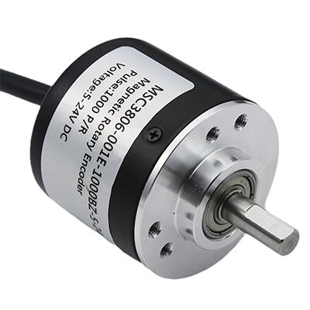
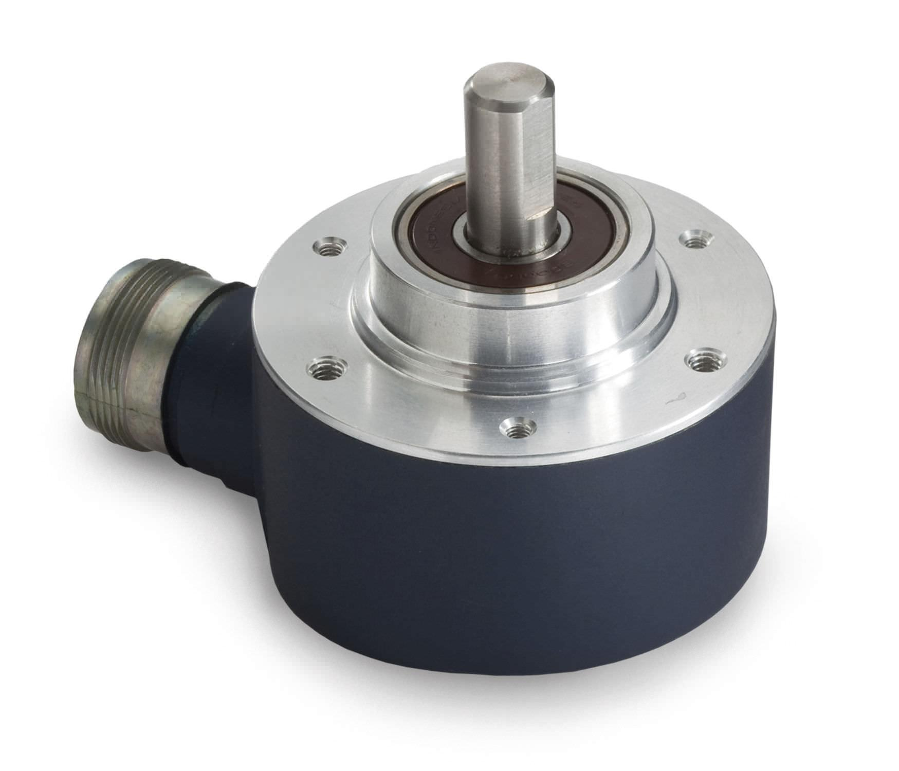
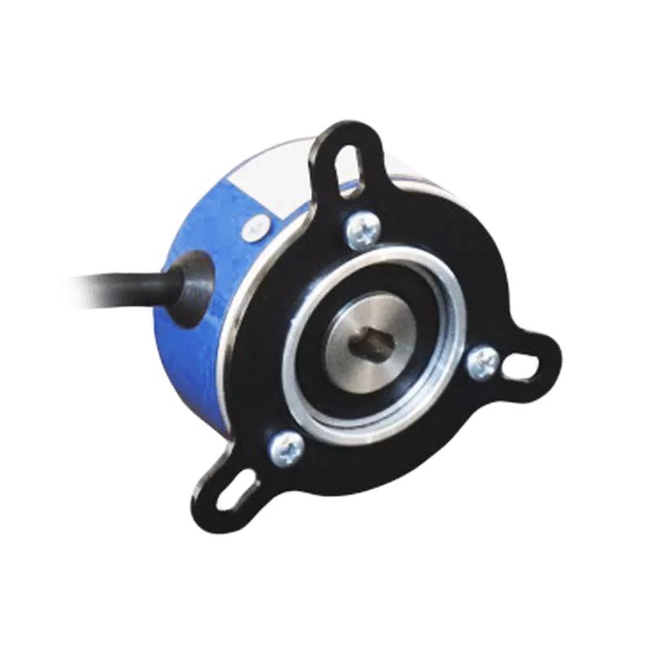
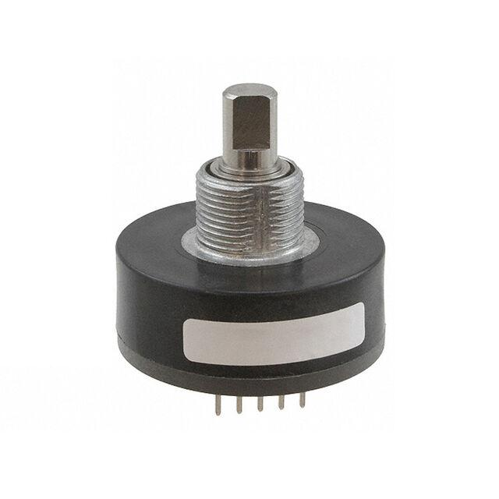
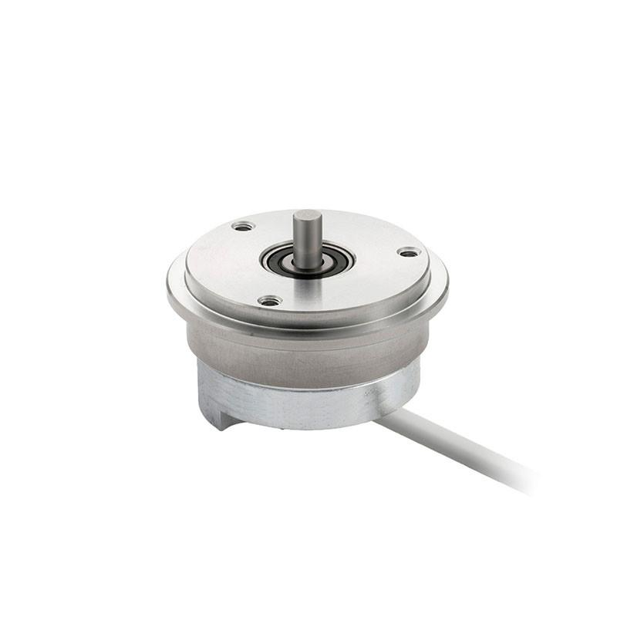
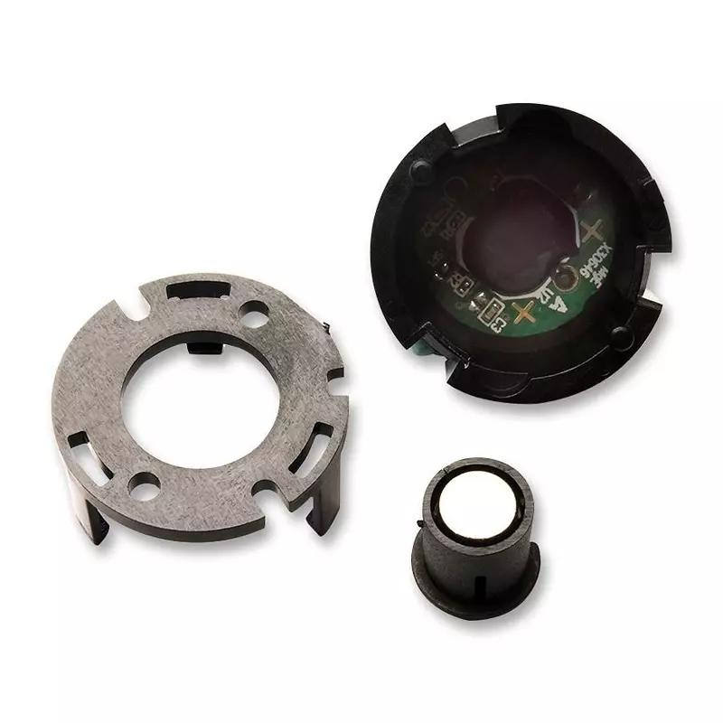
Description
Uses magnetic fields instead of optical disks.
Features
- Resistant to dust and moisture
- Durable in harsh environments
Applications
- Heavy industry
- Automotive systems
- Outdoor machinery

5. Optical Encoder
# Source: AI Source: Provided by: [Data Path: Persons Table -> ID Column: 1, Name_En Column: Motasem Essam] -> From: [ChatGPT] on [7/17/2026]
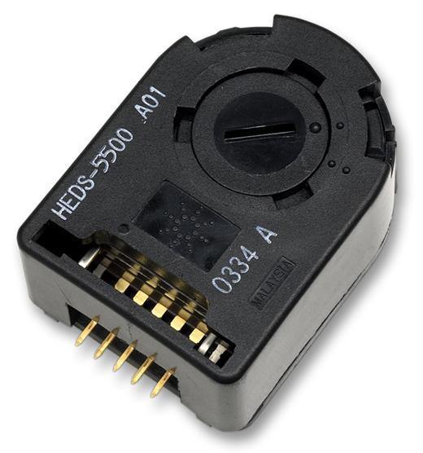

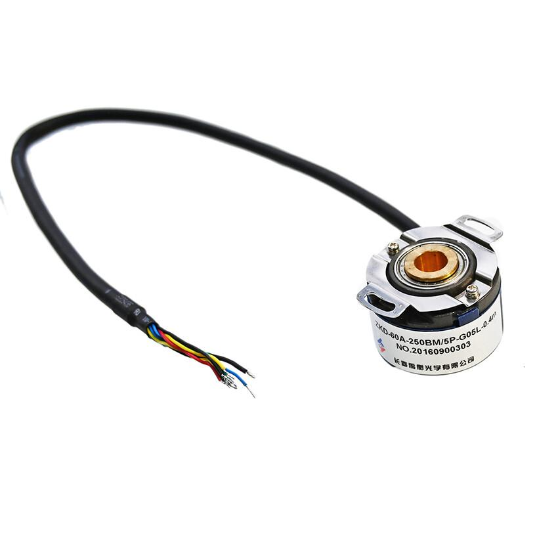
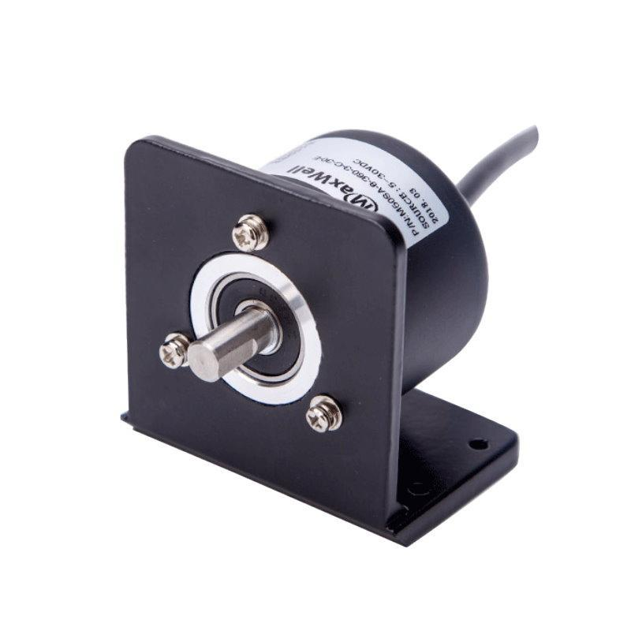
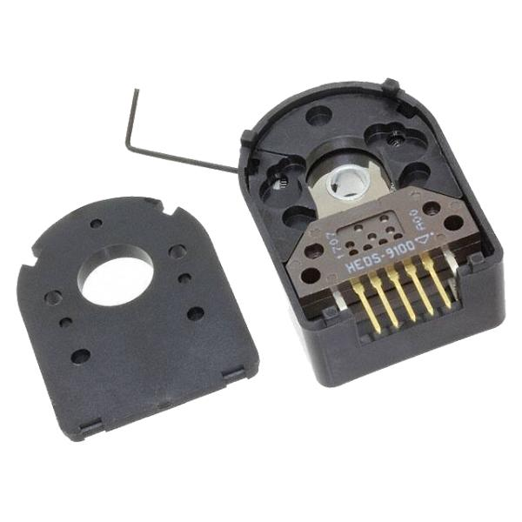
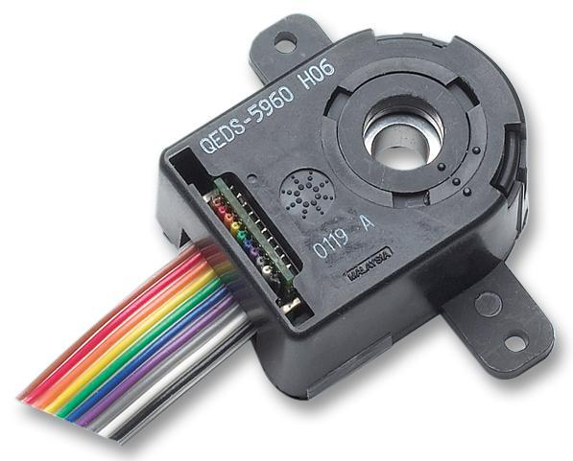
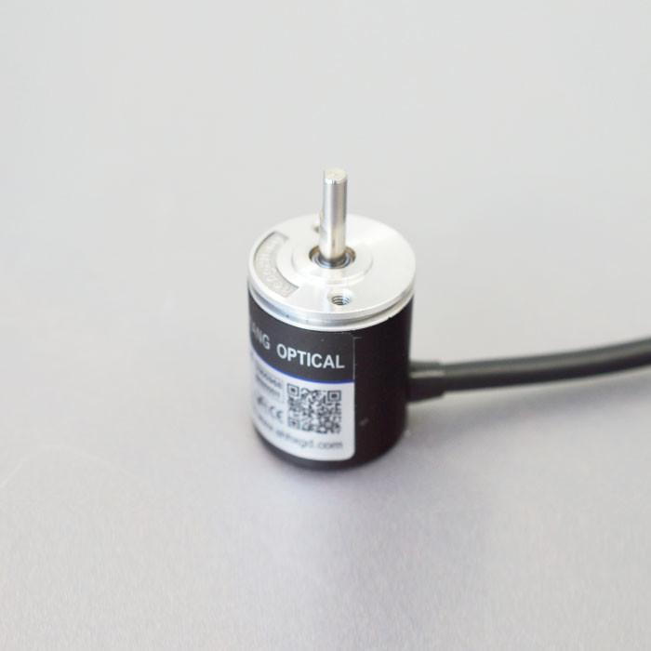
Description
Uses light passing through a coded disk to generate pulses.
Features
- Very high accuracy
- High resolution
- Fast response
Applications
- Precision motion control
- Laboratory equipment
- CNC machinery

Measuring Units
# Source: AI Source: Provided by: [Data Path: Persons Table -> ID Column: 1, Name_En Column: Motasem Essam] -> From: [ChatGPT] on [7/17/2026]
Encoders may provide:
- Revolutions per minute (RPM)
- Pulses per revolution (PPR)
- Counts per revolution (CPR)
- Millimeters (mm)
- Inches (in)

Measuring Range
# Source: AI Source: Provided by: [Data Path: Persons Table -> ID Column: 1, Name_En Column: Motasem Essam] -> From: [ChatGPT] on [7/17/2026]
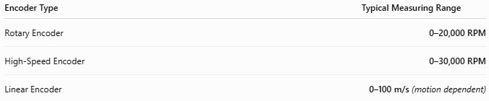
Encoder Type | Typical Measuring Range
Rotary Encoder | 0–20,000 RPM
High-Speed Encoder | 0–30,000 RPM
Linear Encoder | 0–100 m/s (motion dependent)

Resolution
# Source: AI Source: Provided by: [Data Path: Persons Table -> ID Column: 1, Name_En Column: Motasem Essam] -> From: [ChatGPT] on [7/17/2026]
Resolution indicates the smallest detectable movement.
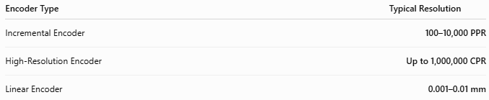
Encoder Type | Typical Resolution
Incremental Encoder | 100–10,000 PPR
High-Resolution Encoder | Up to 1,000,000 CPR
Linear Encoder | 0.001–0.01 mm

Accuracy
# Source: AI Source: Provided by: [Data Path: Persons Table -> ID Column: 1, Name_En Column: Motasem Essam] -> From: [ChatGPT] on [7/17/2026]
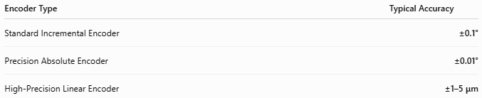
Encoder Type | Typical Accuracy
Standard Incremental Encoder | ±0.1°
Precision Absolute Encoder | ±0.01°
High-Precision Linear Encoder | ±1–5 μm
Notes
- Accuracy depends on encoder quality, mounting, and environmental conditions.
- Optical encoders generally provide the highest resolution and accuracy.
- Absolute encoders eliminate cumulative counting errors after power interruptions.

How to Use an Encoder
# Source: AI Source: Provided by: [Data Path: Persons Table -> ID Column: 1, Name_En Column: Motasem Essam] -> From: [ChatGPT] on [7/17/2026]
- Mount the encoder securely to the rotating shaft or moving axis.
- Connect it to the controller or PLC.
- Configure the encoder parameters (PPR/CPR or resolution).
- Start the motion system.
- Monitor speed, position, or direction from the controller.

Applications
# Source: AI Source: Provided by: [Data Path: Persons Table -> ID Column: 1, Name_En Column: Motasem Essam] -> From: [ChatGPT] on [7/17/2026]
Encoders are used in:
- Industrial automation
- Robotics
- CNC machines
- Servo motors
- Conveyor systems
- Packaging machinery
- Elevators
- Printing presses
- Medical equipment

Advantages
# Source: AI Source: Provided by: [Data Path: Persons Table -> ID Column: 1, Name_En Column: Motasem Essam] -> From: [ChatGPT] on [7/17/2026]
An encoder:
- Provides highly accurate motion feedback.
- Enables precise speed and position control.
- Supports real-time automation.
- Offers long service life.
- Is available in many resolutions and configurations.

Limitations
# Source: AI Source: Provided by: [Data Path: Persons Table -> ID Column: 1, Name_En Column: Motasem Essam] -> From: [ChatGPT] on [7/17/2026]
An encoder:
- Optical models are sensitive to dust and contamination.
- Requires proper alignment during installation.
- High-resolution models can be expensive.
- Some incremental encoders require a homing procedure after power loss.

Sources of Error
# Source: AI Source: Provided by: [Data Path: Persons Table -> ID Column: 1, Name_En Column: Motasem Essam] -> From: [ChatGPT] on [7/17/2026]
Instrument Errors
- Worn bearings
- Damaged encoder disk
- Electronic drift

User Errors
- Misalignment
- Incorrect wiring
- Loose mounting

Environmental Errors
- Dust (optical encoders)
- Moisture
- Strong vibration
- Electromagnetic interference

Comparison with Other Speed Measuring Instruments
# Source: AI Source: Provided by: [Data Path: Persons Table -> ID Column: 1, Name_En Column: Motasem Essam] -> From: [ChatGPT] on [7/17/2026]
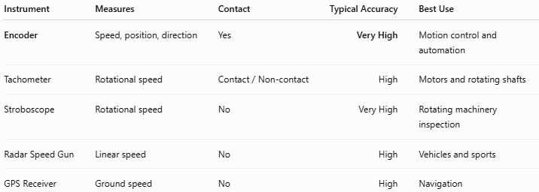
Instrument | Measures | Contact | Typical Accuracy | Best Use
Encoder | Speed, position, direction | Yes | Very High | Motion control and automation
Tachometer | Rotational speed | Contact / Non-contact | High | Motors and rotating shafts
Stroboscope | Rotational speed | No | Very High | Rotating machinery inspection
Radar Speed Gun | Linear speed | No | High | Vehicles and sports
GPS Receiver | Ground speed | No | High | Navigation

Care and Maintenance
# Source: AI Source: Provided by: [Data Path: Persons Table -> ID Column: 1, Name_En Column: Motasem Essam] -> From: [ChatGPT] on [7/17/2026]
To maintain performance:
- Keep the encoder clean.
- Protect optical encoders from dust.
- Ensure proper shaft alignment.
- Check cable connections regularly.
- Replace worn bearings if necessary.

Common Mistakes
# Source: AI Source: Provided by: [Data Path: Persons Table -> ID Column: 1, Name_En Column: Motasem Essam] -> From: [ChatGPT] on [7/17/2026]
- Incorrect shaft alignment.
- Using the wrong encoder type for the application.
- Ignoring electrical noise.
- Improper mounting leading to vibration-induced errors.

Key Points
# Source: AI Source: Provided by: [Data Path: Persons Table -> ID Column: 1, Name_En Column: Motasem Essam] -> From: [ChatGPT] on [7/17/2026]
- An Encoder converts motion into electrical signals.
- It measures speed, position, direction, and displacement.
- Common types:
  - Incremental Encoder
  - Absolute Encoder
  - Linear Encoder
  - Magnetic Encoder
  - Optical Encoder
- Widely used in industrial automation, robotics, CNC machining, and servo systems.

Conclusion
# Source: AI Source: Provided by: [Data Path: Persons Table -> ID Column: 1, Name_En Column: Motasem Essam] -> From: [ChatGPT] on [7/17/2026]
An Encoder is a high-precision motion sensor that converts rotational or linear movement into electrical signals, enabling accurate measurement of speed, position, and direction. Its precision, fast response, and compatibility with modern control systems make it an essential component in industrial automation, robotics, CNC machinery, servo motor control, and advanced manufacturing.

